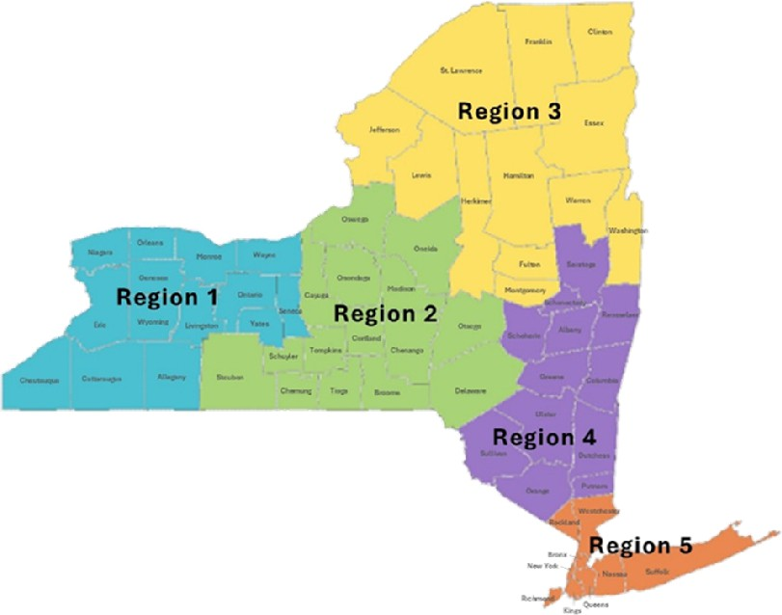

**REGION 3:**

Deborah Collette Cromp: [deborah@teachingimprovesperformance.com](mailto:deborah@teachingimprovesperformance.com)

Clinton, Essex, Franklin, Fulton, Hamilton, Herkimer, Jefferson, Lewis, Montgomery, St. Lawrence, Warren, Washington

**NYS Pyramid Model Regional Coordinators**

**REGION 1:**

Lynn Lubecki: [lynnlubecki@me.com](mailto:lynnlubecki@me.com)

Allegany, Cattaraugus, Chautauqua, Erie, Genesee, Livingston, Monroe, Niagara, Ontario, Orleans, Seneca, Wayne, Wyoming, Yates

**REGION 4:**

Lauren Cohen: [laurencohenpyramid@gmail.com](mailto:laurencohenpyramid@gmail.com)

Albany, Columbia, Dutchess, Greene, Orange, Putnam, Rensselaer, Saratoga, Schenectady, Schoharie, Sullivan, Ulster

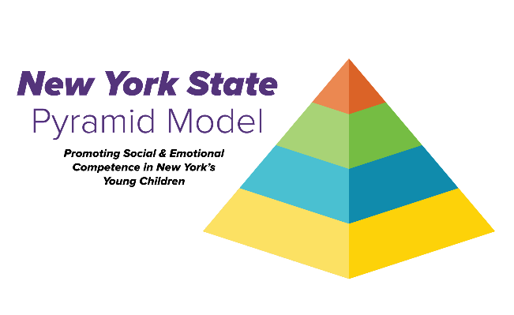

**REGION 5:**

Ke’Shon Mack Brown: [keytrain4success@yahoo.com](mailto:keytrain4success@yahoo.com)

Bronx, Kings, Nassau, Manhattan, Queens, Richmond, Rockland, Suffolk, Westchester

**REGION 2:**

Deb Fitzgerald: [nyspyramidmodel@nyaeyc.org](mailto:nyspyramidmodel@nyaeyc.org)

Broome, Cayuga, Chemung, Chenango, Cortland, Delaware, Madison, Oneida, Onondaga, Oswego, Otsego, Schuyler, Steuben, Tioga, Tompkins