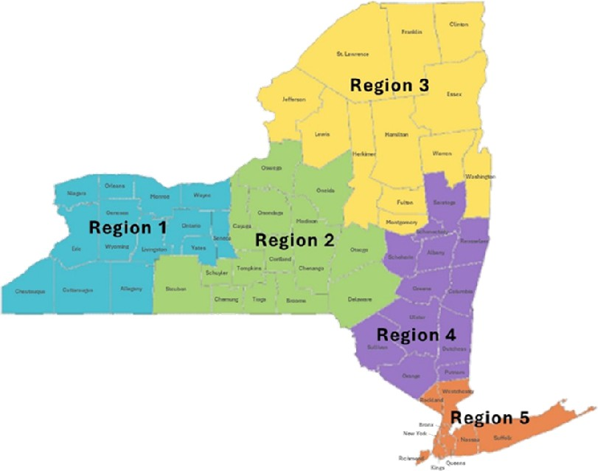
REGION 4:
Lauren Cohen: laurencohenpyramid@gmail.com
Albany, Columbia, Dutchess, Greene, Orange, Putnam, Rensselaer, Saratoga, Schenectady, Schoharie, Sullivan, Ulster

REGION 1:
Lynn Lubecki: lynnlubecki@me.com
Allegany, Cattaraugus, Chautauqua, Erie, Genesee, Livingston, Monroe, Niagara, Ontario, Orleans, Seneca, Wayne, Wyoming, Yates

REGION 3:
Deborah Collette Cromp: deborah@teachingimprovesperformance.com
Clinton, Essex, Franklin, Fulton, Hamilton, Herkimer, Jefferson, Lewis, Montgomery, St. Lawrence, Warren, Washington

NYS Pyramid Model Regional Coordinators

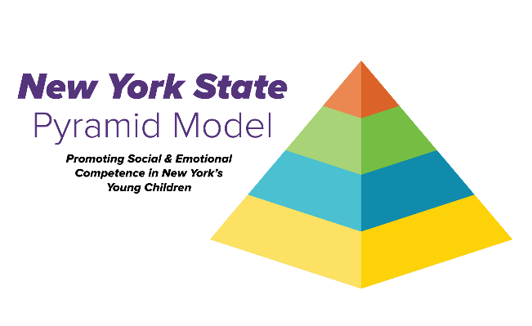
REGION 5:
Ke’Shon Mack Brown: keytrain4success@yahoo.com & Karin Sperb: karinsperb@gmail.com
Bronx, Kings, Nassau, Manhattan, Queens, Richmond, Rockland, Suffolk, Westchester

REGION 2:
Deb Fitzgerald: nyspyramidmodel@nyaeyc.org
Broome, Cayuga, Chemung, Chenango, Cortland, Delaware, Madison, Oneida, Onondaga, Oswego, Otsego, Schuyler, Steuben, Tioga, Tompkins

