NYS Pyramid Model Implementation

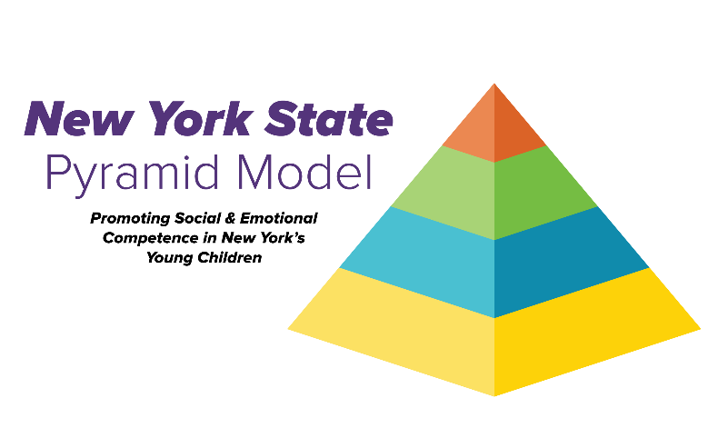
Interested in learning more about Pyramid Model implementation?
Please contact:
nyspyramidmodel@albany.edu

Statewide Directors
Debbie Collette-Cromp:
dcollette-cromp@albany.edu

Ke'Shon Mack- Brown:
kmack-brown@albany.edu

General Pyramid Model Interest:
nyspyramidmodel@albany.edu

